# **Graphene-SGX**

Commands

ISGX_DRIVER_PATH="$HOME/Documents/SGX-real/linux-sgx-driver/" make SGX=1

This is for running graphene with SGX and also providing path

Environment setup is important via SDK before compiling a code

source ${sgx-sdk-install-path}/environment

Like

source /home/maryam/Documents/SGX-real/linux-sgx/linux/installer/bin/sgxsdk/environment

To make it work with SGX kindly do not install graphene driver first, there is error in build documents

ISGX_DRIVER_PATH="$HOME/Documents/SGX-real/linux-sgx-driver/" make SGX=1

ISGX_DRIVER_PATH="/home/maryam/Documents/SGX-real/linux-sgx-driver/"

Or

ISGX_DRIVER_PATH="$HOME/Documents/SGX-real/linux-sgx-driver/"

ISGX_DRIVER_PATH="/Desktop/Sayyaf/graphene-sgx-driver/"

make SGX=1 distclean

After that instal graphen-sgx driver then add sign key in pal folder from graphene main using

openssl genrsa -3 -out Pal/src/host/Linux-SGX/signer/enclave-key.pem 3072

For later run

Run

sudo sysctl vm.mmap_min_addr=0

**Local repository** is successfully generated at /home/maryam/Documents/SGX-real/linux-sgx/linux/installer/deb/local_repo_tool/../sgx_debian_local_repo

After this a update has to be added in **source list**

deb [trusted=yes arch=amd64] file:/home/Documents/SGX-real/linux-sgx/linux/installer/deb/local_repo_tool bionic main

## Quick start:

**pwd** for path directory

openssl genrsa -3 -out Pal/src/host/Linux-SGX/signer/enclave-key.pem 3072

**more better, intell intelSGX_driver then build granphene-SGX after that insert gsgx.ko from graphene-sgx-driver**

Sayyaf Modification: ISGX_DRIVER_PATH="/home/maryam/Desktop/SSGX/linux-sgx-driver-master/"

**In Graphene Main**

ISGX_DRIVER_PATH="/home/maryam/Documents/SGX-real/linux-sgx-driver/"

then add sign key in pal folder from graphene main using

For later run

sudo sysctl vm.mmap_min_addr=0

Run

**sudo insmod gsgx.ko, after restart**

sudo **insmod** gsgx.ko

To run hello worl I used **make SGX=1** instead of make SGX=1 sgx-tokens which made current for running below command.

SGX=1 ./pal_loader helloworld

# **Open-SGX**

<https://01.org/intel-software-guard-extensions/sgx-virtualization>

<https://scontain.com>

_____________

**Below is environment path for non commercial VB**

source /home/bitsym/linux-sgx/linux/installer/bin/awaisdir/sgxsdk/environment

If failed due to some error then kindly reset this environment then run again **./app**

This is SGX guide for Ubuntu to be used by **OpenSGX**

Useful links for OpenSGX GitHub repo and a pdf guide in this repository.

* <https://github.com/sslab-gatech/opensgx>
* <https://drive.google.com/drive/folders/1GTC2FnQzP5YB5VZq_Ac99EOIbJs3qf9-?usp=sharing>

# 

**For creating and running enclave.**

System should be **updated** and upgrated then install **dependencies**, then compile **Qemu** then compile libc and **user** as SGX said. Then

(follow as README.md)

$ ./opensgx -k

generate sign.key

$ ./opensgx -c user/demo/hello.c

generate hello.sgx

$ ./opensgx -s user/demo/hello.sgx --key sign.key

generate hello.conf

$ ./opensgx user/demo/hello.sgx user/demo/hello.conf

run the program

$ ./opensgx -i user/demo/hello.sgx user/demo/hello.conf

run the program with counting the number of executed guest instructions

**Tor** does not make due to version mismatch of automake, so I removed missing file in tor. But still make install does not work properly. Needed work on **missing configurations**

**Sgx-tor is required to be rename as sgx-tor.sgx**

# Libraries Installations

## **Sudo apt-get and sudo apt** update using both of these commands

To use

sudo apt-get build-dep qemu, **check open sources** in updates, or uncomment dep-src from source list.

<https://askubuntu.com/questions/826890/apt-build-dep-fails-unable-to-locate-source-package-despite-deb-src-lines-pres>

## Qemu - other [way](https://www.itzgeek.com/how-tos/linux/ubuntu-how-tos/install-kvm-qemu-on-ubuntu-14-10.html)

sudo apt-get install qemu //install

Sudo apt-get install qemu-kvm // install kvm pakages

apt show qemu-system-x86 // to check qemu version

## Updating sources files [Ubuntu 14 req]

1. Backup sources .list from /etc/apt/sources.list
2. Change pk.archive.ubuntu to **old-releases.**ubuntu….
3. Comment any previous old-release links to remote duplicate problem
4. Ignore few errors if come

## Downgrade automake [ubuntu 16]

From automake 1.15 to automake 1.14 required for compiling Tor files

Google search these….

1. error: version mismatch. This is Automake 1.15.1 but the definition … comes from Automake 1.14.1
2. Automake-1.14 is failing at make
3. One of worked solution which result a error but that is because of newer version of **perl pakage** so install older pakage from 5.22 <https://askubuntu.com/questions/623891/how-to-downgrade-from-automake1-14-to-1-12-version>
4. <https://blog.geekuni.com/2015/05/how-to-install-different-versions-of-perl.html> to change perl version.

## ***Pictures:***

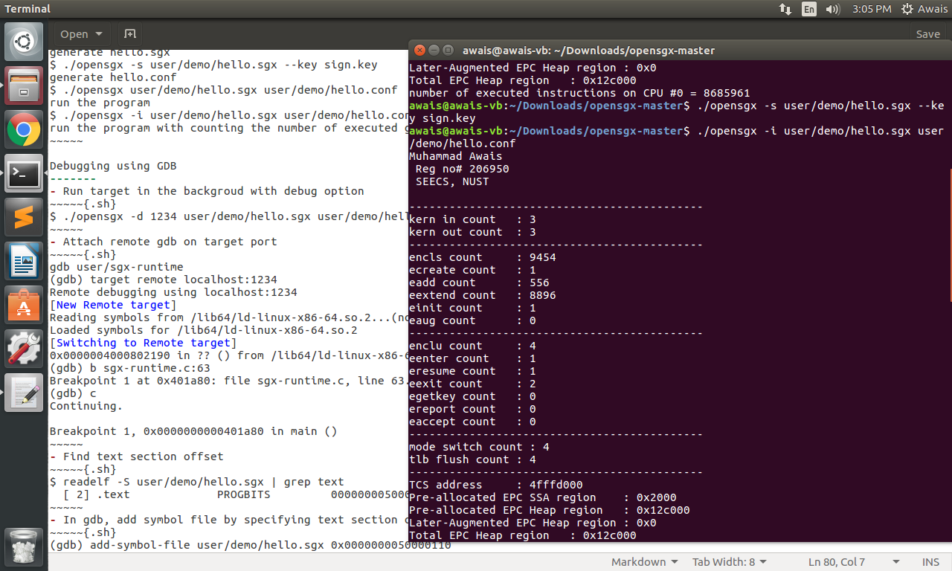

**Ref:**

<https://drive.google.com/drive/folders/17mVWQOSfeK6bWx1Ddx9VeJ2TK6zN1WJF?usp=sharing>

**Paper data**

== Submission Guidelines ==

Papers must describe original research that advances state-of-the-art research and must not be simultaneously submitted to a journal or a conference with proceedings. Papers must be written in excellent English and should not exceed 20 pages. Previously published or accepted conference papers must contain at least 50% new material to be considered for the special issue. A covering letter to the Guest editors clearly describing the extensions made must accompany these types of submissions. All submissions must be made using the instructions available at:

<http://annalsoftelecommunications.wp.mines-telecom.fr/how-to-publish/>

The authors can directly submit their papers at: <https://www.editorialmanager.com/ante/> and must select “Open Topic” in the menu “Choose Article Type” and then in the questionnaire on the “Additional Information” section, they will be able to select the item “CfP: Interactions between artificial intelligence and cybersecurity to protect future networks”.

= Important Dates ==

Manuscript Submission: Extended to February 28, 2021

Online with DOI: As soon as accepted

Printed Issue: Second half of 2021

== Topics ==

Topics of interest for this special issue include but are not limited to:

AI for the Cybersecurity of next-generation networks

Anomaly detection

Malware detection

Botnet detection

Root cause analysis

Security information and event management

DPI and network forensics, including encrypted traffic analysis

Countermeasure selection

Moving Target Defense

Intelligent honeypots

Dataset generation

Attack generation

Adversarial examples and Robustness

Critical analysis of AI/ML applied to Cybersecurity

Security of AI-based next-generation networks

Security and privacy in AI algorithms

Security in intelligent systems

Trust in AI platforms

Security and privacy of BigData processing

Formal verification of AI algorithms

Evasion/Deception of AI algorithms

Adversarial examples and Robustness

#include <stdio.h>

#include <stdlib.h>

void main()

{

char fname[20], ch;

FILE *fpts, *fptt;

printf("\n\n Encrypt a text file :\n");

printf("--------------------------\n");

printf(" Input the name of file to encrypt : ");

scanf("%s",fname);

fpts=fopen(fname, "r");

if(fpts==NULL)

{

printf(" File does not exists or error in opening..!!");

exit(1);

}

fptt=fopen("temp.txt", "w");

if(fptt==NULL)

{

printf(" Error in creation of file temp.txt ..!!");

fclose(fpts);

exit(2);

}

while(1)

{

ch=fgetc(fpts);

if(ch==EOF)

{

break;

}

else

{

ch=ch+100;

fputc(ch, fptt);

}

}

fclose(fpts);

fclose(fptt);

fpts=fopen(fname, "w");

if(fpts==NULL)

{

printf(" File does not exists or error in opening..!!");

exit(3);

}

fptt=fopen("temp.txt", "r");

if(fptt==NULL)

{

printf(" File does not exists or error in opening..!!");

fclose(fpts);

exit(4);

}

while(1)

{

ch=fgetc(fptt);

if(ch==EOF)

{

break;

}

else

{

fputc(ch, fpts);

}

}

printf(" File %s successfully encrypted ..!!\n\n", fname);

fclose(fpts);

fclose(fptt);

}